Modern Business Concept Using Ethereum Blockchain Platform And Google Cloud Platform In Agribusiness

Annur Hangga Prihadia1**,** Is Mardiantoa2**,** Iwan Purwantoa3

aFaculty of Industrial Technology, Trisakti University

Jakarta, Indonesia

1annur065001800028@std.trisakti.ac.id (Corresponding author)

[2mardianto@std.trisakti.ac.id](mailto:2mardianto@std.trisakti.ac.id)

[3iwan.purwanto@std.trisakti.ac.id](mailto:3iwan.purwanto@std.trisakti.ac.id)

***Abstract***

*Blockchain technology is the choice in technological developments that promote peer-to-peer systems, and decentralized data. The supply chain process in the agribusiness sector currently uses traditional technology where the data of agribusiness products are stored in traditional databases. Blockchain technology has the potential to change the process to be more modern due to transparency in every activity to facilitate tracking and visibility of goods in the supply cause easier auditability of records, for example Carrefour Italia reported that it has implemented a food tracking system with blockchain. The author focuses on building business solutions on supply chain transparency in the agribusiness sector with the Minimum Viable Product target in the form of Txn supply chain processes. The author uses the Ethereum with its Smart Contract products to build a business system in blockchain. The author needs to identify the functions needed to use the Ethereum to implement business processes and blockchain systems to be run. The product of this research is a prototype blockchain system that generates Txn in supply chain processes for transparency in ongoing supply chain business activities.*

***Keywords:*** *Blockchain, Ethereum, Smart Contract, Supply Chain, Txn*

# Introduction

Blockchain technology is widely recognized as an innovative option for developing technologies that facilitate peer-to-peer distributed information systems for corporate data. Blockchain technology facilitates digital currency transactions. In its current development, blockchain can update decentralized currency systems such as Bitcoin, Ethereum smart contracts, the Binance smart chain and other resources that can be managed online.

Blockchain technology allows organizations to exchange data and complete transactions in minutes without the need for intervention or verification by third parties such as banks when processing customer transactions.

Blockchain technology also ensures the security of distributed information exchange. This may have a significant impact on the management of the organization. It can also change the way companies In the supply chain, building relationships and sharing products and information.

Today, agribusiness supply chains are highly structured, global, and interconnected. Information and documentation of agribusiness products on safety, sustainability, procurement and other features. Information is often recorded and stored on paper or in private databases and can only be viewed by trusted third parties. In this situation accessing data becomes expensive, time consuming, and requires action, distortion, and error that threatens the loss of business processes especially in the financial field.

Although the trend of the digital economy continues, agricultural products are still included in one of the fewest digital industries. Blockchain technology can affect this situation in a different way i.e. the food sector can benefit from decentralized digital smart contracts that operate independently and automatically to process transactions and automation between participants in the supply chain.

The purpose of this study is to model the blockchain system that builds Txn in the supply chain process to ensure that ongoing business activities in the supply chain are transparent. Research limitations as follows Minimum Viable Product in the form of Txn occurs between supply chains, Using the Ethereum network, Using a smart contract that resides on the Ethereum network.

# Reseach Methods

## Ethereum Architecture

The core idea behind the Ethereum architecture is how users perform smart contract functions built to support the business needs of the blockchain. Writed with smart contracts this architecture shows how interconnected technologies that allow the Ethereum ecosystem to work to create blockchain-based blocks containing transaction data from users. A mining node is a mining machine that monitors transactions carried out on the Ethereum blockchain network, and each block contains information already described in Figure 1.

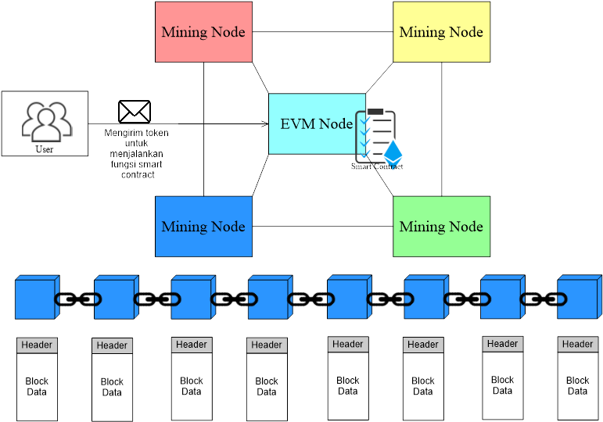

**Figure 1.** Ethereum Architecture

## Cloud Architecture

In the picture below, it can be seen that the researcher uses the GCP service to make his CMS site online, namely with the Deployment Manager which has been directly integrated with Compute Engine and VPC to facilitate work.

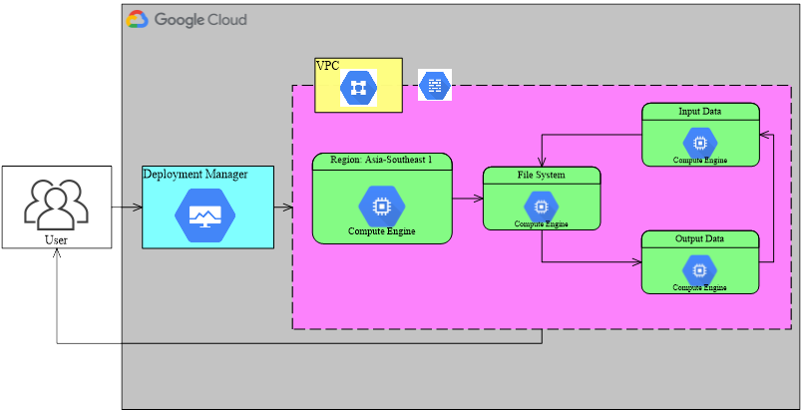

**Figure 2.** Cloud Architecture

## Create a Smart Contract

In the image below the user needs to install the MetaMask application and create an Ethereum account to get the Ethereum address that the user will use. When creating a smart contract deployed to the Ethereum network will cost money. So first check if the user has Ethereum (ETH) by joining the airdrop or buying from a broker. Once you own Ethereum (ETH) you can then open the Remix Ethereum IDE using Ethereum’s dedicated development environment at the following link (remix.ethereum.org) users can create and edit smart contracts to use according to business needs. An example of a smart contract from a researcher can be accessed via the following link (https://github.com/hanggaa/PrototypeThesis/blob/ma in/Token/Skripsi/.workspaces/Skripsi2/hangga.sol) The smart contract created by the researcher works when creating a new token running on the Ethereum network, allowing entities to send tokens between entities as a condition for writing data on the blockchain. After creating or modifying the smart contract the next step is to match it with the compiler. Regardless of whether the Solidity version matches or not, if it does not match, the compilation process will fail. The next step is to compile the smart contract. After a successful compile process the user can run the smart contract on the EVM node or on the Ethereum network. The deployment process is done by selecting Injected Web3 (MetaMask) as the deploy payment method.

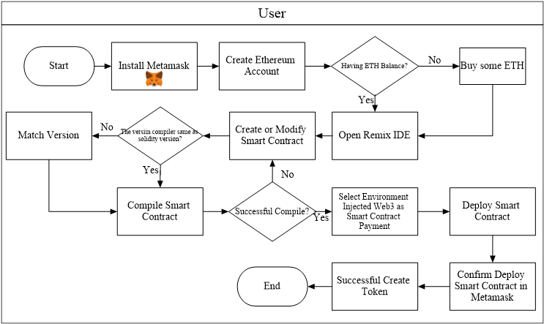

**Figure 3.** Flow to Create a Smart Contract

## QR Code

The user copies the website link stored in the QR Code, pastes the link into the QR Code, then generates a system that converts it into a QR Code and prints it out while simultaneously assigning it as the product label.

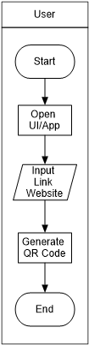

**Figure 4.** Flow to Create and Printing The QR Code

## Installing Tokens on Metamask

When installing a token on Metamask the user needs to copy the token contract address that can be opened through the token creation transaction details, after the transaction details are open then copy the token contract address and select "Add Custom Token" in MetaMask. After the custom token opens paste the token address that was copied earlier.

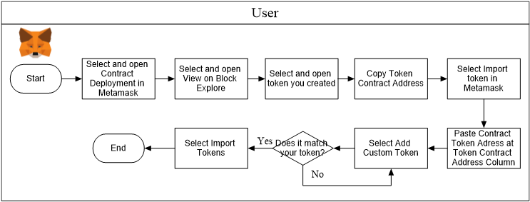

**Figure 5.** Install Smart Contract Tokens on MetaMask

## Supply Chain Business Processes Using Blockchain

It can be seen that all entities (except Retail) create labels of goods to be recorded in the blockchain. Before buying goods between entities, you can read the data on the blockchain through a QR Code affixed to the goods to see the entities that worked in the previous supply chain process.

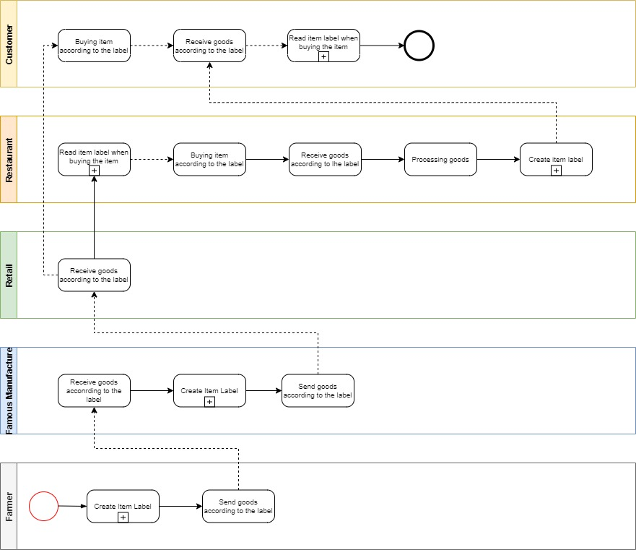

**Figure 6.** Supply Chain Business Process Using Blockchain (Famous Manufacturer) Level 1

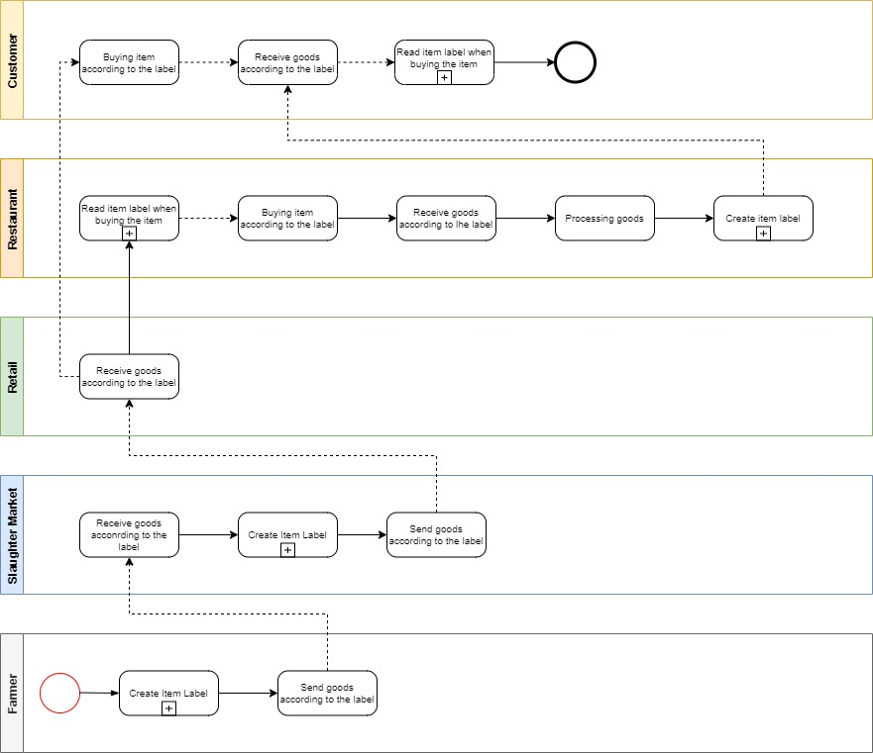

**Figure 7.** Supply Chain Business Process Using Blockchain (Slaughteer Market) Level 1

The picture below is a detail of the activity of creating goods labels and reading labels when you want to buy products, in the process of creating goods labels between entities, it is necessary to enter data into the Blockchain by sending the tokens that have been created to the address used by the next entity so that the data transactions are recorded into the blockchain. Once the data is successfully recorded into the blockchain the next step is for the inter-entities to enter the data into the CMS according to their respective businesses. The browser site link resulting from the data entered into the CMS is converted into a QR Code by the inter-entity and then pasted into the product so that consumers can see the browser site containing Txn (Required) and others.

When consumers read the item label, simply scan the QR Code affixed by the supply chain entity to the item to see the supply chain process transactions on the blockchain. Of course, consumers can see the origin of the goods to be purchased (Depending on the agreement between the parties).

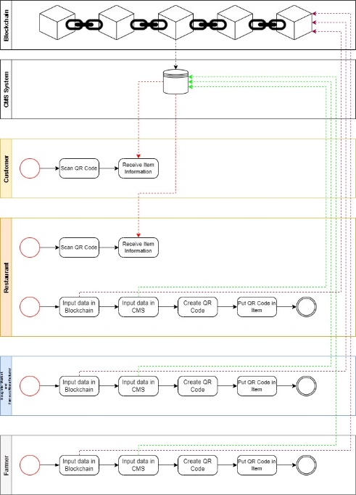

**Figure 8.** Supply Chain Business Process Using Blockchain (Slaughter Market/Famous Manufacturer) Level 2

# Result

## Implementation

Some of the specifications, tools, and versions needed in this study are

1. Python version 3.8 to run a CMS
2. Wagtail Library with Django Framework
3. GCP Instance of Asia-southeast zone1-a
4. GCP Instances of e2-medium machine type
5. Pragma solidity version 0.4.24
6. ERC-20 Tokens

## Creating a Smart Contract

Researchers created HAJW tokens with smart contracts using the solidity programming language version 0.4.24.

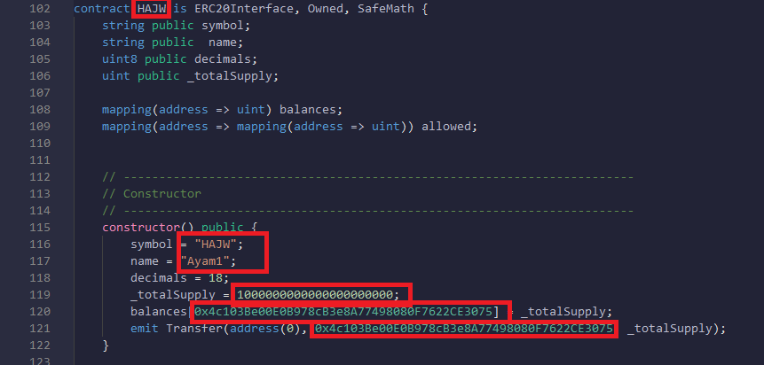

**Figure 9.** Smart Contract Modification

Researchers matched a pragma version of solidity with a compiler version of the Remix IDE.

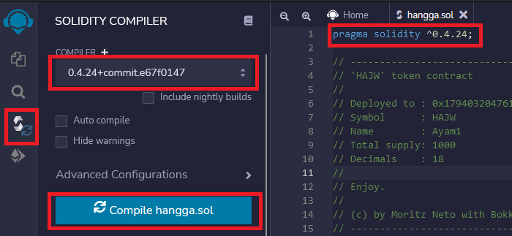

**Figure 10.** Compile Smart Contract

In the picture below , it can be seen that the researcher successfully compiled the smart contract, if an error occurs or an error then the smart contract must be re-modified.

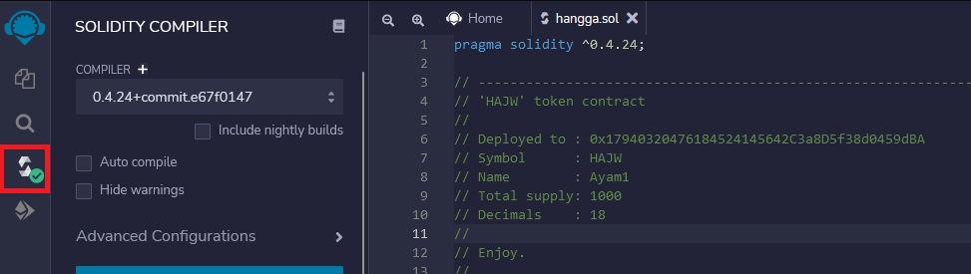

**Figure 11.** Successful Compile Smart Contract

Researchers chose an Injected Web3 environment connected to an Ethereum account located on MetaMask to pay for deployment fees and be associated with the blockchain.

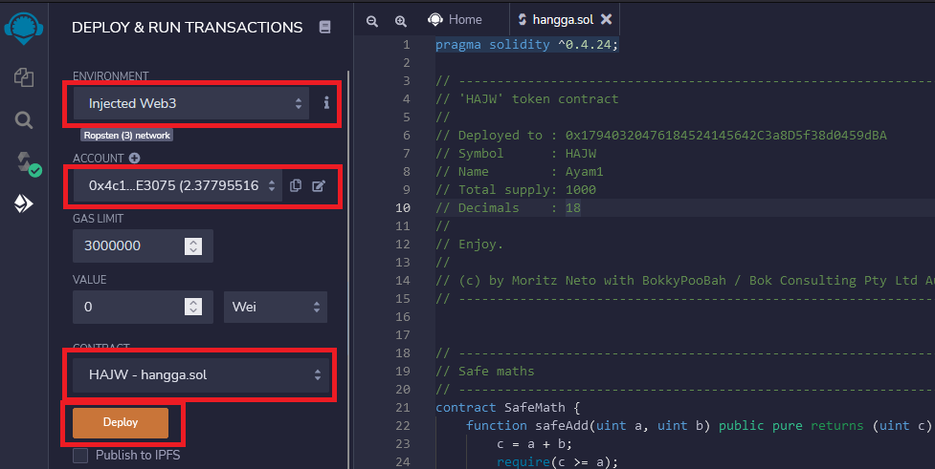

**Figure 12.** Deploy Smart Contracts With Injected Web3

In the picture below, it can be seen that the process of deploying a smart contract in token creation costs 0.00361184 ETH (Ether).

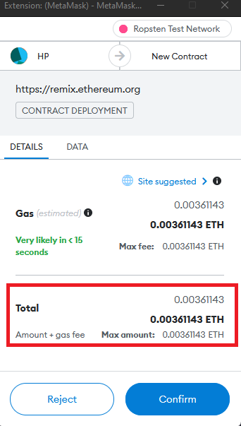

**Figure 13.** Confirm Deploy Smart Contract

Next activity after payment of the smart contract deployment fee which can then continue the process of deploying into the blockchain. If the deployment has been successful then a MetaMask popup will appear.

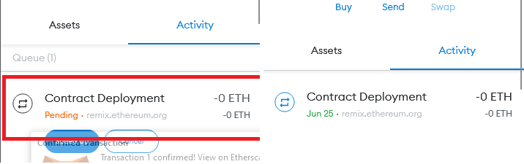

**Figure 14.** Deploy Smart Contract Activity

## Input CMS

The image below is the first component encapsulated in a card element containing

Photos or images of items purchased by customers

The name of the item purchased by the customer

Blockchain links of senders and receivers of supply chain entity

Txn blockchain links

Reference links from previous supply chain processes

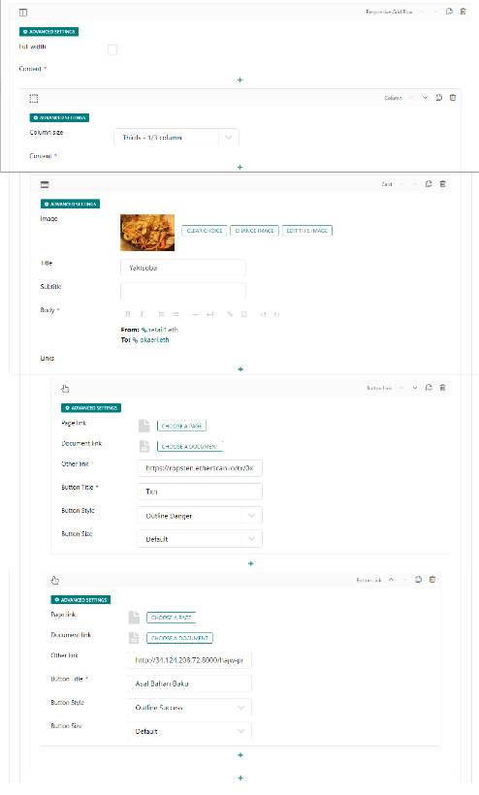

**Figure 15.** Column 1 Web Page

The picture below is a content that describes the goods.

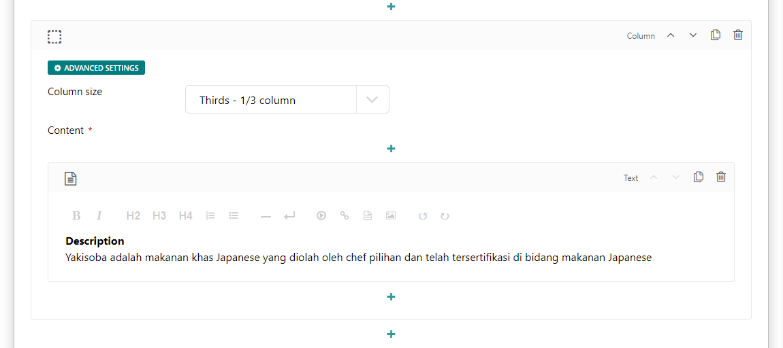

**Figure 16.** Column 2 Web Page

On Figure 17 is a component that displays a map of supply chain actors. The content entered into the site page is the right of each entity, researchers create content as above because the content of the content is very transparent to be understood by customers.

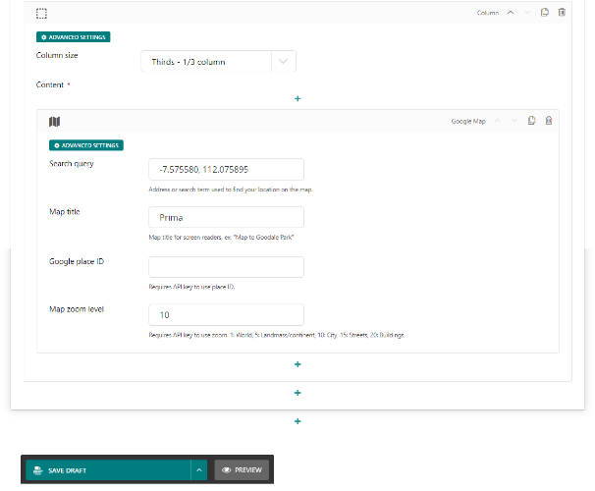

**Figure 17.** Column 3 Web Page

## Logistics and Transport Process

The picture below is a supply chain process that begins with a purchase order activity (Purchase Order) to the depot, then the depot validates the order and sends an expedition report as well as an order to the warehouse. In the warehouse, the token transfer process and load planning allocation and expeditions are carried out to be assembled as well as validated orders before being delivered to retail. If the order is not appropriate when at retail, there will be a Proof of Delivery (POD) process where the retail and depot parties must fill out a form according to existing cases such as damaged/lost/exchanged goods, lack in products (missed in product) and other cases.

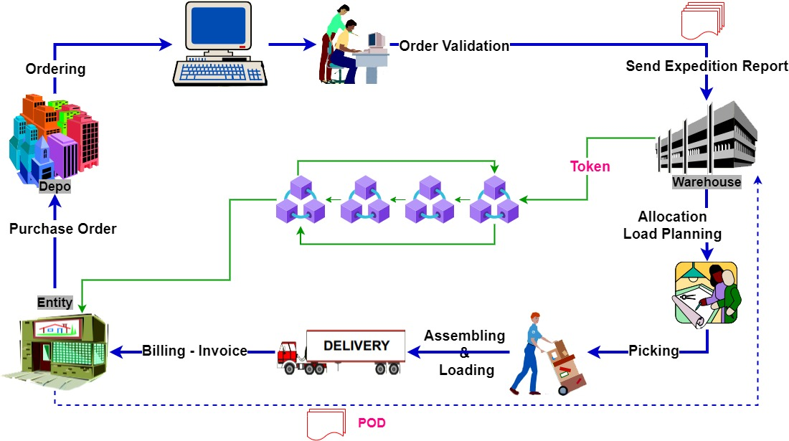

**Figure 18.** Supply Chain Process

## Use of GCP (Google Cloud Platform) Services

In this study, researchers used the Django Packaged by Bitnami deployment manager to deploy the CMS so that the CMS site was online.

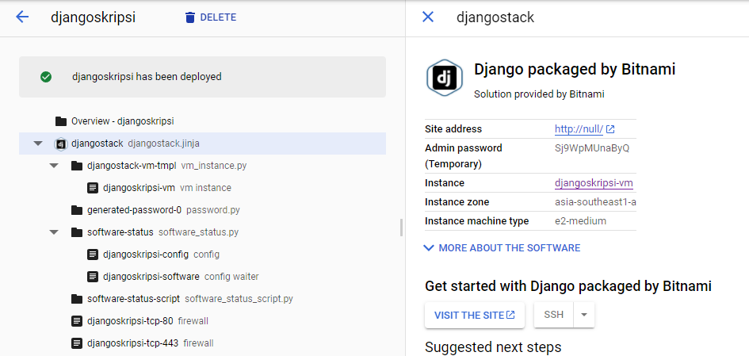

**Figure 19.** Djangostack Deployment Manager view

In the Compute Engine service there is a view of the server instance with the following details

Name is the name of the compute engine instance, djangoskripsi-vm.

Zone is the location of the compute engine instance region zone located in asiasoutheast1-a (Southeast asia region zone).

Internal IP is the IP used to set the server instance.

External IP is the most important part because external IP will be used to access the CMS.

Connect is a place to connect to an SSH server.

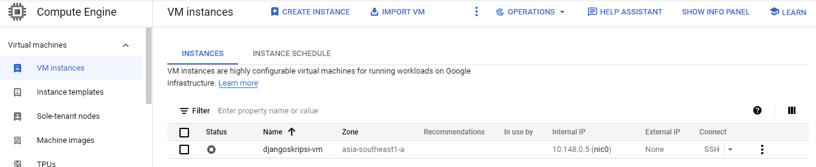

**Figure 20.** Server Instance View

In a VPC network, there are network settings so that you can access the external IP consisting of

1. Name is the name of the firewall setting
2. Type is an option of whether the network is linked to another GCP network service
3. Targets are which targets will be linked to the firewall settings that have been set.
4. Filters contain the IP range that will be used to run the server.
5. Protocols/ports contain number ports whose function is to be able to see the cms site display.

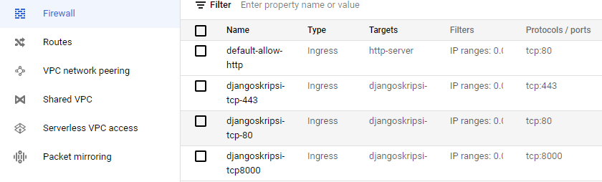

**Figure 21.** Firewall Settings view

## Print QR Code

The image below is a QR Code System maker which contains a link field and files name that must be filled in by users to get the QR Code as shown in Figure 23. The QR Code above will display the link and move the customer to the predetermined link so that customers can see the process of the raw material supply chain until it is processed at the restaurant.

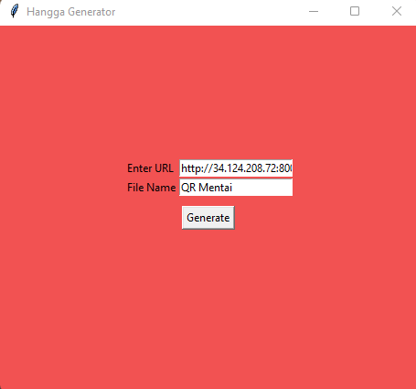

**Figure 22.** QR Code Generator System Display



**Figure 23.** QR Code Result

## Website Display

After the user scans the QR Code, a web page like Figure 24 will appear which contains according to what has been entered in the CMS such as photos of purchased goods, information in the blockchain, descriptions of goods, maps of places of supply chain entities. Users can see the information in the blockchain when selecting the Raw Materials Txn button to ascertain whether it is true that the Ethereum addresses of supply chain actors work together.

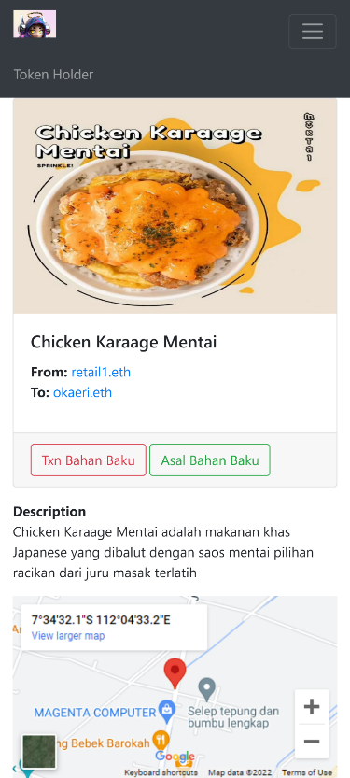

**Figure 27.** Website View After User Scans QR Code

# Conclusion

Smart contracts make it easy between entities to get in touch with the blockchain

The design of this system successfully proves that supply chain transactions from upstream to downstream can be recorded on the blockchain

Each entity will find it easier to see blockchain transaction data because transaction data is very transparent.

In blockchain transactions, there is a gas fee or transfer fee, so it should be between entities to think of a special budget for the gas fee.

Using Google Cloud Platform services makes it easy to host a CMS

**References**

1. C. Supaartagorn, "Web Application for Automatic Code Generator," pp. 114-117, 2017.
2. C. Supaartagorn, "Web Application for Automatic Code Generator Using a Structured Flowchart," pp. 114-117, 2017.
3. N. Sulaiman, S. Sakinah and S. Ahmad, "Logical Approach: Consistency Rules between Activity Diagrams and Class Diagrams," Advanced Science Engineering Information Technology, vol. 9, no. 2, pp. 552-559, 2019.
4. J.-G. Song, M. Sung-Jun and J. Ju-Wook, "A Scalable Implementation of Anonymous Voting over Ethereum Blockchain," Sensors, vol. 21, no. 3958, pp. 1-19, 2021.
5. A. K. Shrestha, J. Vassileva and R. Deters, "A Blockchain Platform for User Data Sharing Ensuring User Control and Incentives," vol. 3, pp. 1-22, 2020.
6. H. Shah, M. Shah, S. Tanwar and N. Kumar, "Blockchain for COVID-19: a comprehensive review," Personal and Ubiquitous Computing, pp. 1-28, 2021.
7. G. A. Motta, B. Tekinerdogan and N. Athanasiadis, "Blockchain Application in the Agri-Food Domain: The First Wave," vol. 3, pp. 1-13, 2020.
8. A. Maghfirah and Hara, "Blockchain in Food and Agriculture Supply Chain: Use-Case of Blockchain in Indonesia," International Journal of Food and Beverage Manufacturing and Business Models, vol. 4, no. 2, pp. 53-66, 2019.
9. H.-J. Kim and e. al, "Smart Decentralization of Personal Health Records with Physician Apps and Helper Agents on Blockchain: Platform Design and Implementation Study," JMIR Medical Informatics, vol. 9, no. 6, pp. 1- 14, 2021.
10. I. T. Javed, F. Alharbi, B. Bellaj, T. Margaria, N. Crespi and K. Naseer, "Health-ID: A Blockchain-Based Decentralized Identity," Healtcare, vol. 9, no. 712, pp. 1-21, 2021.
11. A. Hasselgren, Jens-Andreas, K. Kralevska, D. Gligoroski and A. Faxvaag, "Blockchain for Increased Trust in Virtual Health Care:," Journal Medical Internet Research, vol. 23, no. 7, pp. 1-15, 2021.
12. G. Gursoy, C. M.Brannon and M. Gerstein, "Using Ethereum blockchain to store and query pharmacogenomics data via smart contracts," BMC Medical Genomics, vol. 13, no. 74, pp. 1-11, 2020.
13. C. D. Clack, "A Blockchain Grand Challenge: Smart Financial Derivatives," vol. 1, no. 1, pp. 1-3, 2018.
14. M. S. Al-Rakhami and M. Al-Mashari, "A Blockchain-Based Trust Model for the Internet of Things Supply Chain Management," sensors, vol. 21, no. 1759, pp. 1-15, 2021.
15. M. S. Ali, M. Vecchio, G. D. Putra and S. S. Kanhere, "A Decentralized Peer-to-Peer Remote Health Monitoring System," Sensors, vol. 20, no. 1656, pp. 1-18, 2020.
16. K. e. al, "Smart Decentralization of Personal Health Records with Physician Apps and Helper Agents on Blockchain: Platform Design and Implementation Study," JMIR MEDICAL INFORMATICS, vol. 9, no. 6, pp. 1-14, 2021.
17. A. Akhtar, A. Afzal, B. Shafiq, S. Shamail, J. Vaidya and O. Rana, "Blockchain Based Auditable Access Control for," International Conference on Distributed Computing Systems (ICDCS), vol. 40, pp. 12-22, 2020.